ASSIGNMENT-01
ROLL NO:-2303A51632
BATCH NO:-25
TASK-1:-
Task 1: AI-Generated Logic Without Modularization (Factorial without
Functions)
• Scenario
You are building a small command-line utility for a startup intern onboarding
task. The program is simple and must be written quickly without modular
design.
• Task Description
Use GitHub Copilot to generate a Python program that computes a
mathematical product-based value (factorial-like logic) directly in the main
execution flow, without using any user-defined functions.
• Constraint:
➢ Do not define any custom function
➢ Logic must be implemented using loops and variables only
• Expected Deliverables
➢ A working Python program generated with Copilot assistance
➢ Screenshot(s) showing:
➢ The prompt you typed
➢ Copilot’s suggestions
➢ Sample input/output screenshots
➢ Brief reflection (5–6 lines):
➢ How helpful was Copilot for a beginner?
➢ Did it follow best practices automatically?
PROMPT:-
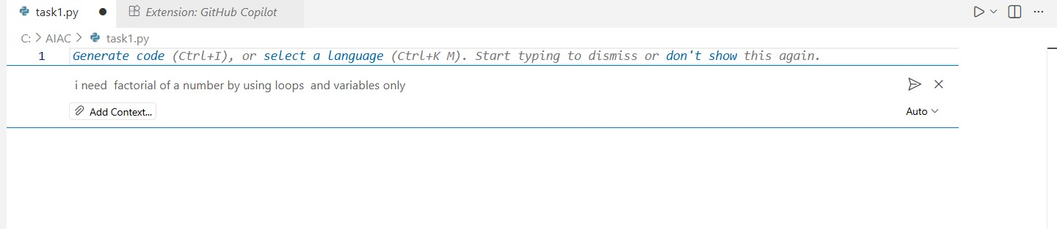
CODE:-
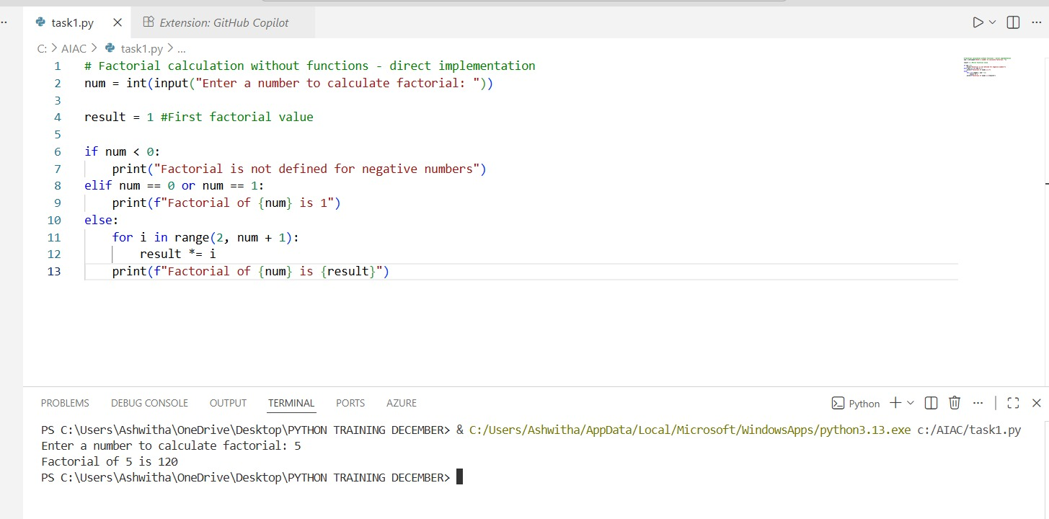
EXPLANATION:-
This program calculates the factorial of a number entered by the user.
If the number is negative, it prints that factorial is not defined; if the number is 0 or 1, it prints 1, otherwise it uses a loop to multiply numbers from 2 to the given number and prints the final factorial.

TASK-2:-
Task 2: AI Code Optimization & Cleanup (Improving Efficiency)
❖ Scenario
Your team lead asks you to review AI-generated code before committing it to
a shared repository.
❖ Task Description
Analyze the code generated in Task 1 and use Copilot again to:
➢ Reduce unnecessary variables
➢ Improve loop clarity
➢ Enhance readability and efficiency
Hint:
Prompt Copilot with phrases like
“optimize this code”, “simplify logic”, or “make it more readable”
❖ Expected Deliverables
➢ Original AI-generated code
➢ Optimized version of the same code
➢ Side-by-side comparison
➢ Written explanation:
▪ What was improved?
▪ Why the new version is better (readability, performance,
maintainability.
PROMPT:-
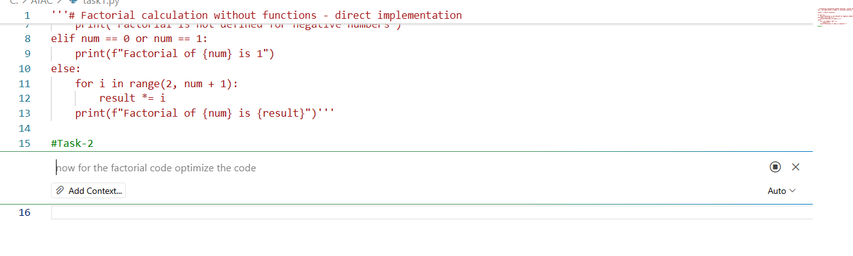
CODE:-
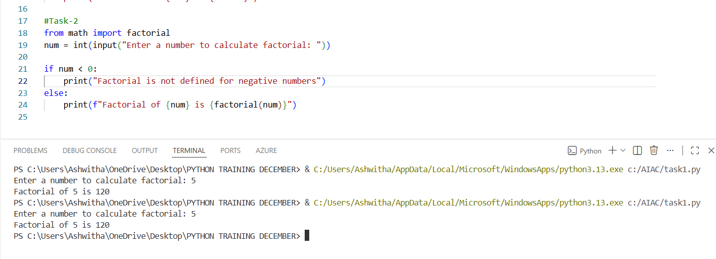
EXPLANATION:-
The optimized version removes unnecessary conditions while keeping the logic correct. This makes the code shorter and easier to read, which helps in understanding and maintaining it. Even after simplification, the program produces the same output and runs with the same performance as the original version.
TASK-3:-
Task 3: Modular Design Using AI Assistance (Factorial with Functions)
❖ Scenario
The same logic now needs to be reused in multiple scripts.
❖ Task Description
Use GitHub Copilot to generate a modular version of the program by:
➢ Creating a user-defined function
➢ Calling the function from the main block
❖ Constraints
➢ Use meaningful function and variable names
➢ Include inline comments (preferably suggested by Copilot)
❖ Expected Deliverables
➢ AI-assisted function-based program
➢ Screenshots showing:
o Prompt evolution
o Copilot-generated function logic
➢ Sample inputs/outputs
➢ Short note:
o How modularity improves reusability
PROMPT:-
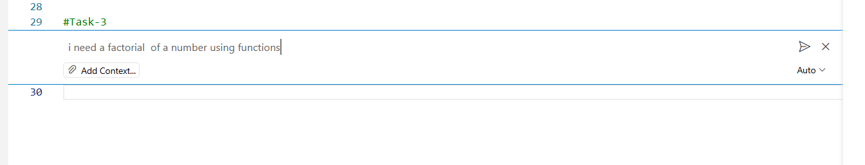
CODE:-
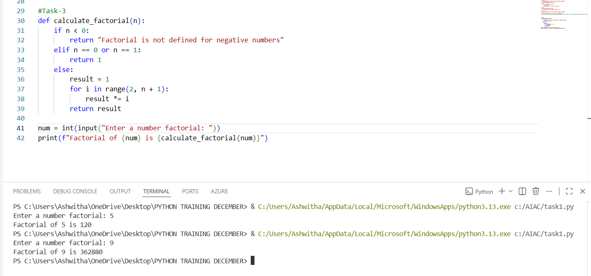
EXPLANATION:-
The improved version removes unnecessary conditions but keeps the logic intact. This makes the code shorter and easier to read, which aids in understanding and maintaining it. Even after this simplification, the program still produces the same output and runs at the same performance level as the original version.
TASK-4:-
Task 4: Comparative Analysis – Procedural vs Modular AI Code (With vs
Without Functions)
❖ Scenario
As part of a code review meeting, you are asked to justify design choices.
❖ Task Description
Compare the non-function and function-based Copilot-generated
programs on the following criteria:
➢ Logic clarity
➢ Reusability
➢ Debugging ease
➢ Suitability for large projects
➢ AI dependency risk
❖ Expected Deliverables
Choose one:
➢ A comparison table
OR
➢ A short technical report (300–400 words).
PROMPT:-
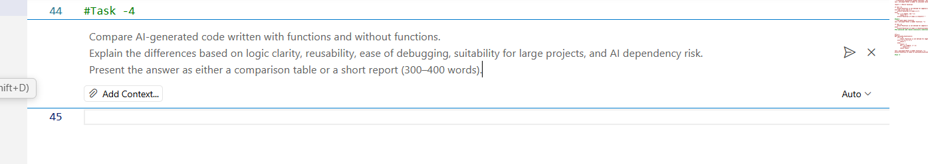
CODE:-
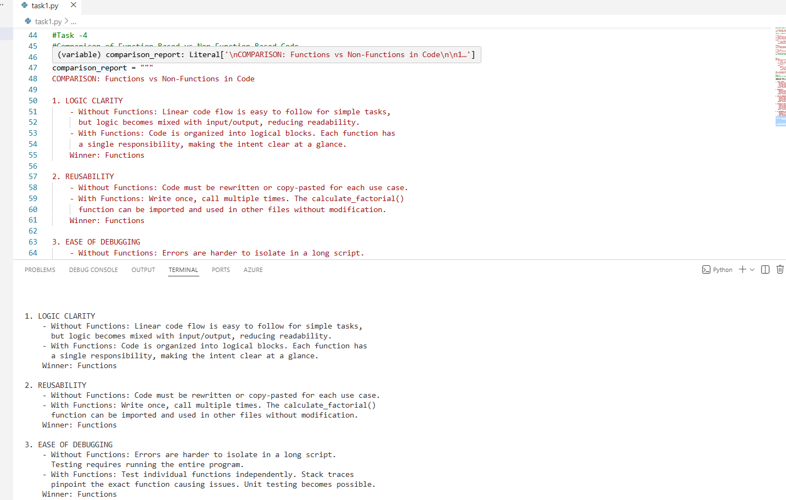
EXPLANATION:-
Function-based code is better than non-function code because it makes the program easier to understand, reuse, and debug. Functions divide the logic into clear parts, which helps in finding errors quickly and makes the code suitable for large projects. Non-function code may work for small or quick tasks, but it becomes hard to manage as the program grows. Overall, using functions is the professional and reliable approach, especially when working with AI-generated code.
TASK5:-

Task 5: AI-Generated Iterative vs Recursive Thinking
❖ Scenario
Your mentor wants to test how well AI understands different
computational paradigms.
❖ Task Description
Prompt Copilot to generate:
An iterative version of the logic
A recursive version of the same logic
❖ Constraints
Both implementations must produce identical outputs
Students must not manually write the code first
❖ Expected Deliverables
Two AI-generated implementations
Execution flow explanation (in your own words)
Comparison covering:
➢ Readability
➢ Stack usage
➢ Performance implications
➢ When recursion is not recommended.
PROMPT:-
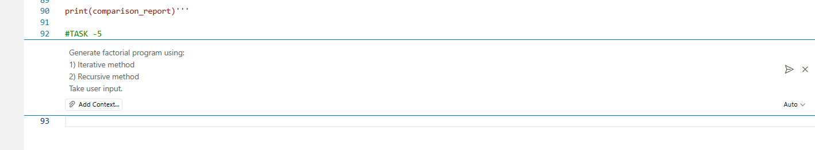

CODE:-
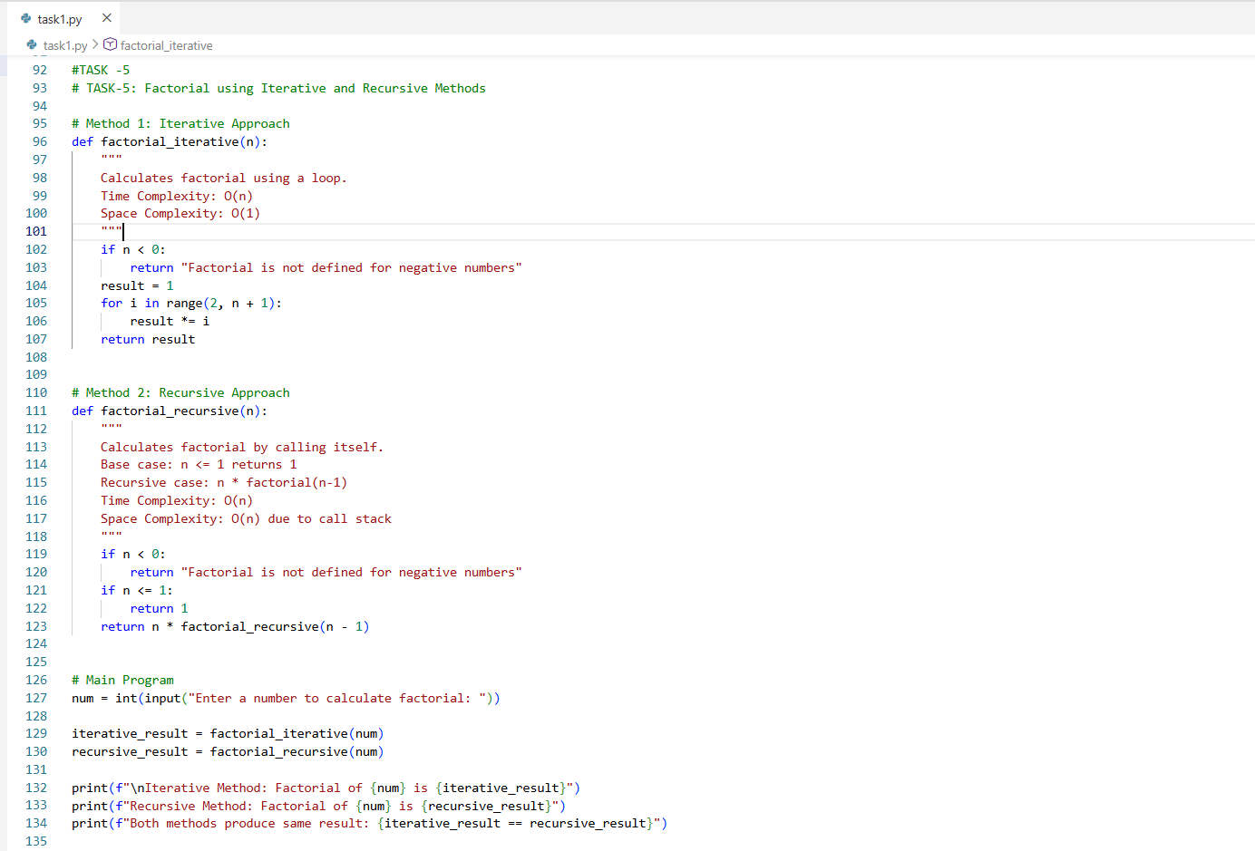

EXPLANATION:-
The program calculates the factorial of a number using both a loop (iterative method) and a function that calls itself (recursive method), and both give the same result.
The iterative method uses less memory and is safer, while the recursive method is simpler to write but uses more stack memory.

